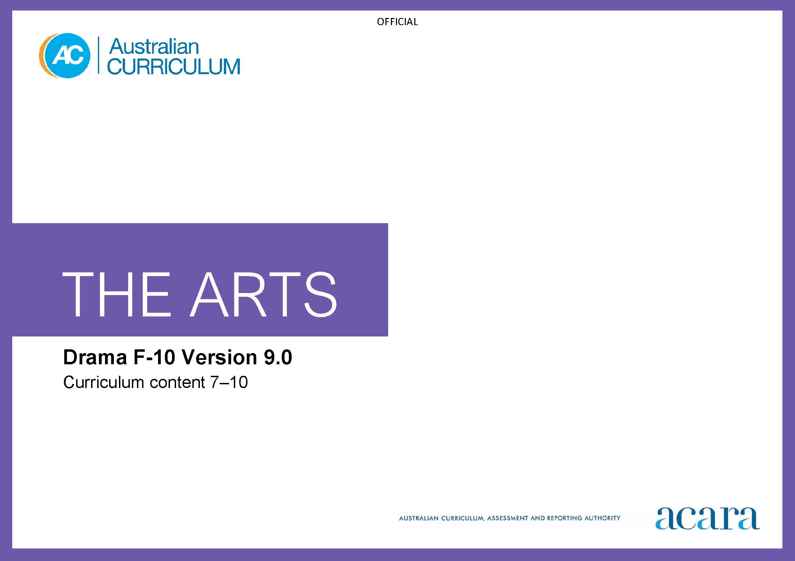

Copyright and Terms of Use Statement
© Australian Curriculum, Assessment and Reporting Authority 2022
The material published in this work is subject to copyright pursuant to the Copyright Act 1968 (Cth) and is owned by the Australian Curriculum, Assessment and Reporting Authority (ACARA) (except to the extent that copyright is held by another party, as indicated).
The viewing, downloading, displaying, printing, reproducing (such as by making photocopies) and distributing of these materials is permitted only to the extent permitted by, and is subject to the conditions imposed by, the terms and conditions of using the ACARA website (see, especially, clauses 2, 3 and 4 of those terms and conditions). The terms and conditions can be viewed at https://www.acara.edu.au/contact-us/copyright
TABLE OF CONTENTS
Curriculum elements 3
Years 7–8 3
Years 9–10 8

Curriculum elements

Years 7–8
Band level description
In this band, learning in Drama builds on each student’s prior learning and experiences. Students learn in and through the practices of Drama: creating, performing and responding. They use drama processes in purposeful and creative ways, and continue to develop their connection with and contribution to the world as artist and as audience. They work individually and in collaboration with peers and teachers.
Students explore drama in local, regional, national and global contexts such as drama in countries or regions of Asia, including use of drama in multi-arts, trans-disciplinary or hybrid forms. They take opportunities to engage with living performers and drama-makers, and expand their awareness of diverse drama practices, genres and/or styles.
In this band, the focus is on students:
- exploring and responding to
  - drama works, performances, practices and contexts from a range of cultures, times and places; for example, through analysis of their own drama or the work of others, including professional work
  - the diversity of drama created and/or performed by First Nations Australians and how this work demonstrates respect for Indigenous Cultural and Intellectual Property rights
- developing practices and skills
  - creative practices for creating and performing drama using the elements of drama: role, situation, language, place, movement, time, character, relationships, voice, tension, space, mood/atmosphere, contrast, symbol and focus, and conventions relevant to selected forms and/or styles
  - critical practices by taking opportunities to reflect on, evaluate or respond to their own work and the work of others; for example, documenting ideas and intentions for devised drama, evaluating their own or others’ responses to drama, reflecting on their own performances
- creating drama in improvised, devised and scripted forms such as process drama, puppetry, object theatre, short- or long-form improvisation, play-building and devising, scripted drama/text interpretation; for example, interpretation of realism and/or non-realism, exploration of historic, contemporary or hybrid styles
- presenting and performing drama in informal and/or formal settings; for example, performing for a specific target audience.
Achievement standard
By the end of Year 8, students analyse how elements of drama and/or conventions are manipulated in drama they create and/or experience. They evaluate the ways drama created and/or performed across cultures, times, places and/or other contexts communicates ideas, perspectives and/or meaning. They describe respectful approaches to creating, performing and/or responding to drama.
Students work collaboratively to manipulate elements of drama and conventions to shape and sustain dramatic action in improvised, devised and/or scripted drama. They employ performance skills to convey dramatic action and communicate ideas, perspectives and/or meaning when performing drama to audiences.

Strand: Exploring and responding |  | Years 7–8
Content descriptions  Students learn to: | Content elaborations  This may involve students:
investigate ways the elements of drama and/or conventions are used to communicate ideas, perspectives and/or meaning in drama created and/or performed across cultures, times, places and/or other contexts  AC9ADR8E01 | - researching and noticing how the impact of time and place/context of a drama from a particular period can differ from that of another period, particularly in relation to the use of drama conventions  - using Viewpoints to analyse and evaluate performances they have experienced and/or participated in by asking questions such as “What ideas did you think the drama expressed?”, “What conventions were used to establish time/place/context?”, “How was movement used in the drama?”  - writing or pod/vodcasting a review of a drama they experience, focusing on use of specific elements of drama and/or conventions; for example, identifying and describing how an element of drama has been manipulated to communicate ideas, perspectives and/or meaning  - analysing how linear and non-linear narrative is used in examples of drama from diverse cultures; for example, in contemporary drama from countries or regions in Asia or in drama from historical times
investigate the diversity of drama created and/or performed by First Nations Australians, considering culturally responsive approaches to Indigenous Cultural and Intellectual Property rights  AC9ADR8E02 | - identifying how diverse examples of drama created and/or performed by First Nations Australians can consider and demonstrate culturally responsive approaches to Indigenous Cultural and Intellectual Property rights  - using information from Indigenous Cultural and Intellectual Property protocols and guidelines to inform decisions about whether or not ideas from an existing source featuring cultural expressions can be used when developing new drama work  - engaging in activities that enable understanding of how to make ethical choices and empathise with content creators and story owners; for example, asking questions such as, “Whose story is it?”, “Is this my story to share or should I ask permission to tell it?”  - investigating specific examples of how drama practitioners select and use First Nations Australians’ historical and cultural material to develop and create contemporary First Nations Australian theatre; for example, using historical and cultural materials that accurately communicate First Nations Australian perspectives, such as resilience to the impacts of colonisation  - identifying and analysing what cultural appropriation is and how to avoid it by considering the original purpose, context and intended audience of cultural expressions; for example, using advice from protocols for protecting Indigenous Cultural and Intellectual Property rights

Strand: Developing practices and skills |  | Years 7–8
Content descriptions  Students learn to: | Content elaborations  This may involve students:
develop performance skills relevant to selected drama styles and/or forms  AC9ADR8D01 | - developing vocal qualities of projection, clarity and contrast through control of pace, pitch, dynamics and use of pause and silence  - developing use of the body to communicate through, for example, movement and stillness, realistic and non-realistic movement; and developing performance skills such as exploring ways to transition between scenes  - experimenting with ways to use conventions associated with a specific style/form in their drama; for example, conventions such as flashback/flashforward, aside, slow motion, chorus (commentator), signs, sound/music  - experimenting with the elements of drama, relevant stylistic conventions or ways of manipulating form to create, shape and sustain dramatic action, situations and narratives, in order to achieve intended meaning and purpose; for example, through class, individual and group activities such as improvisation and basic devising in a selected style or in response to provided stimulus material  - using improvisation to explore techniques/strategies associated with specific styles/forms to heighten and release tension and using ideas from the improvisation to interpret scenes from a scripted drama  - experimenting with ways to manipulate elements of drama and use performance skills to communicate status/power relationships in drama being devised and/or when interpreting scripts  - understanding the importance of and applying respectful relationships and empathy when developing roles and characters, and conveying historical and cultural ideas and meaning
reflect on their own and others’ drama to inform choices when manipulating elements of drama and/or conventions to shape dramatic action  AC9ADR8D02 | - reflecting, independently and in class discussion, upon the action created in order to evaluate and analyse what was effective and make decisions about what would be done differently in future; for example, discussing whether the purpose was achieved, whether the action was engaging, whether the elements could have been managed differently for better effect, and which of the elements worked well to make meaning clear  - seeking, accepting and responding to feedback to inform choices about use of elements of drama and/or conventions; for example, using Viewpoints to develop questions such as “How did the performer use language/movement to make their character believable?”, “What ideas/perspectives/meaning did the drama communicate?”, “What do you think will/could/should happen next?”, “How would you describe the relationship/s between the characters in this scene?”  - developing understanding of human behaviours and emotions using appropriate boundaries, by recalling and re-enacting past experiences and people they have observed in situations relevant to the text or content being used; asking “What did my/their body do?”, “How did my/their voice sound/communicate meaning in the situation?”, “How can I adapt my facial expression, posture, gesture, movement and voice/vocalisation to portray age, power or attitude?”, “How can I express character relationships through vocal dynamics, eye contact, distance and space?”  - reflecting on how performance skills are used to communicate perspectives; for example, how performance skills can be used in drama that seeks to communicate ideas such as perpetuating or challenging unequal power relationships and oppression

Strand: Creating and making |  | Years 7–8
Content descriptions  Students learn to: | Content elaborations  This may involve students:
improvise and devise drama and/or interpret scripted drama, manipulating elements of drama and applying conventions relevant to the style/form  AC9ADR8C01 | - identifying dramatic potential in teacher-provided/directed starting points such as research, examples of the conventions of drama forms/performance styles, dramatic text, the structuring of forms, or discussion of peers’ responses to an issue or topic; then using improvisation and processes such as “mantle of the expert” to develop situations, characters, and make decisions that shape the resulting dramatic action  - using play-building to develop a series of scenes as a class response to an inquiry question or responding to dramatic potential of an image by imagining, “What’s happening? What has happened? What’s going to happen next?”  - working collaboratively to interpret scripted drama; for example, deciding where/when the action will take place, using improvisation to explore and understand characters and relationships, applying conventions relevant to the style/form, blocking use of the performance space to establish context, relationships or transitions, selecting/sourcing and rehearsing with props/set items  - using Viewpoints to frame questions to interpret, analyse and evaluate the effectiveness of dramatic forms, elements, design and conventions or making decisions about how to communicate idea, effects and intentions; for example, “What were the actor’s/director’s intentions in this drama?”, “What ideas did you think the drama expressed?”, “How did you engage with the drama?”  - employing voice/vocalisation and movement appropriate to situation, and manipulating space and time in dramatic action to heighten tension, focus action and shape meaning  - using feedback, reflection or evaluation to develop and extend ideas when improvising, devising and/or scripting drama
evaluate and refine use of elements of drama and/or conventions to shape and sustain dramatic action and/or communicate ideas, perspectives and/or meaning  AC9ADR8C02 | - refining drama during the rehearsal process by using feedback, evaluation, documentation and personal reflection, after using Viewpoints to ask questions such as “What are your intentions in the drama you are making?”, “Is the meaning clear?”, “How could elements, conventions, design (costume, props, setting) and performance skills (voice and movement) be used differently to achieve these effects?”  - adjusting performance based on audience response; for example, character's portrayal of emotion or delivery of lines to make meaning clear  - planning, organising and rehearsing dramatic action to stage devised and scripted drama; for example, arranging use of available theatre technologies and collaborating in rehearsal to stage drama for a clear and intended purpose and effect, considering choices within the overall structure  - considering how and why empathy should be considered when creating effects and communicating intended meaning; for example, exploring conventions for developing characters and stories in drama from a range of cultures

Strand: Presenting and performing |  | Years 7–8
Content descriptions  Students learn to: | Content elaborations  This may involve students:
rehearse and perform improvised, devised and/or scripted drama to audiences, using performance skills and conventions relevant to style and/or form  AC9ADR8P01 | - performing and using conventions relevant to style, suiting choices to the underlying dramatic structure  - collecting and evaluating audience feedback to enhance future performance  - using Viewpoints to ask reflective questions such as “What were your intentions in the drama?”, “Was meaning made clear for the audience?”, “What audience reaction or feedback did you get to suggest it was engaging?”  - respecting Indigenous Cultural and Intellectual Property rights when performing drama that explores First Nations Australians’ perspectives on themes and issues such as identity, resilience, oppression or environmental practices  - reflecting on how respectful relationships and empathy were applied in their performance, and interpreted by the audience

Years 9–10
Band level description
In this band, learning in Drama continues to build on each student’s prior learning and experiences as students develop their capability and confidence across the practices of Drama: creating, performing and responding. They continue to use drama processes in purposeful and creative ways that are informed by their engagement with the work of living performers and drama-makers from across local, regional, national and global contexts, such as countries or regions in Asia, including use of drama in multi-arts, trans-disciplinary and/or hybrid forms. This awareness of diverse drama practices, genres and/or styles informs their own drama practice. They work collaboratively with peers and teachers.
In this band, the focus is on students:
- exploring and responding to
  - drama works, performances, practices and contexts from a range of cultures, times and places; for example, through analysis of their own drama or the work of others, including professional work
  - ways in which drama created and/or performed by First Nations Australians celebrates and challenges multiple perspectives of Australian identity
- developing practices and skills
  - building and extending creative practices for creating and performing drama using the elements of drama: role, situation, language, place, movement, time, character, relationships, voice, tension, space, mood/atmosphere, contrast, symbol, focus and conventions relevant to selected forms and/or styles
  - building and extending critical practices by taking opportunities to reflect on, evaluate or respond to their own work and the work of others; for example, documenting ideas and intentions for script interpretations, analysing their own and others’ use of elements of drama, and evaluating their own performances
- creating drama in improvised, devised and scripted forms such as process drama, puppetry, object theatre, short- or long-form improvisation, play-building and devising, scripted drama/script interpretation; for example, interpretation of realism and non-realism, exploration of historic, contemporary and/or hybrid styles
- presenting and performing drama in informal and/or formal settings; for example, using acting skills and working in an ensemble to perform drama for familiar and unfamiliar audiences.
Achievement standard
By the end of Year 10, students analyse how and why the elements of drama, performance skills and/or conventions are manipulated in drama they create, perform and/or experience. They evaluate how drama in a range of styles and/or from a range of contexts communicates ideas, perspectives and/or meaning. They evaluate how drama is used to celebrate and challenge perspectives of Australian identity.
Students work individually and/or collaboratively to shape and manipulate use of the elements of drama, conventions and/or dramatic structures to communicate ideas, perspectives and/or meaning. They use performance skills relevant to style and/or form to sustain belief, roles and characters in performances of improvised, devised and/or scripted drama for audiences.
Strand: Exploring and responding |  | Years 9–10
Content descriptions  Students learn to: | Content elaborations  This may involve students:
investigate use of elements of drama, performance skills and/or conventions to communicate and/or challenge ideas, perspectives and/or meaning in drama across cultures, times, places and/or other contexts  AC9ADR10E01 | - viewing a performance and considering how aspects of the dramatic action use elements of drama, such as symbol or movement, to make meaning; for example, a suitcase as a symbol for a person’s memories  - investigating ways drama texts can be created and developed collaboratively to create; then reading a text to notice meaning/s created and intentions achieved through selection and combination of elements, conventions or styles  - viewing examples of a variety of styles or forms within a style, such as historical and modern comedy forms and styles from Australia or Asia, or work that reflects “global culture”, to identify and understand how various conventions are shared and how they differ across the styles; then discussing which might be their preferred style  - using Viewpoints to ask questions that consider contexts; for example, considering drama created in countries or regions in Asia or through collaboration between drama-makers in Asia and Australia, and considering questions such as “How does the drama relate to the social context in which it was created?”, “What cultural movements are evident in this drama?”, “What historical influences have impacted on this drama?”, “What is the actor–audience relationship in different dramatic contexts, forms and styles?”  - viewing or reading and exploring examples of historical texts and styles from a range of cultural traditions where artists have used the conventions of contemporary performance, such as mediatisation or intertextuality, or styles such as physical theatre, non-realist or emerging/innovative forms, to affect meaning and for various purposes; then unpacking this as a foundation for their own creative process  - identifying conventions of a collaborative, improvised style to communicate ideas or intentions to audiences; for example, to satirise or to elicit change; then considering how they, as artists, could use these creative tools for their own purposes
investigate the ways that drama created and/or performed by First Nations Australians celebrates and challenges multiple perspectives of Australian identity  AC9ADR10E02 | - investigating and researching specific examples of how and why drama practitioners work collaboratively with communities to develop and present contemporary First Nations Australian theatre  - considering how global trends in drama are influencing drama created and/or performed by First Nations Australians  - investigating specific examples of how contemporary First Nations Australian theatre explores and challenges concepts and histories of Australia and Australian identity  - comparing and critiquing ways in which contemporary drama and cultural expressions celebrate and challenge influences on Australia's identity
Strand: Developing practices and skills |  | Years 9–10
Content descriptions  Students learn to: | Content elaborations  This may involve students:
develop performance skills and/or techniques to manipulate elements of drama and/or use conventions to communicate the physical and psychological aspects of roles and characters consistent with intentions  AC9ADR10D01 | - experimenting with, reflecting on and refining the use of styles and conventions that have been explored in class in order to shape action; for example, considering how contemporary performance, non-realistic or innovative conventions can be used to re-shape or make a new meaning for a scene from a classic text; then workshopping the conventions and forms of comedy and shaping them into a short scene or applying them to a short piece of text  - using analysis of examined text and performances to provide information for exploring and refining the implied or underlying aspects of character and dramatic action in a text or devised action  - refining their skills of voice/vocalisation through warm-ups or exercises focusing on character and delivery or movement
reflect on their own and others’ drama or practices to refine and inform their use of elements of drama, conventions and/or approaches to shape and sustain dramatic action  AC9ADR10D02 | - comparing use of conventions to explore and challenge power and oppression in a range of performance styles  - analysing and making choices about how to manipulate elements of drama and experimenting with the application of conventions, such as subtext or beats, to affect meaning, focus action or shape a scene  - shaping their use of elements of drama, conventions and styles to achieve an intended meaning or effect

Strand: Creating and making |  | Years 9–10
Content descriptions  Students learn to: | Content elaborations  This may involve students:
improvise and devise drama, and interpret scripted drama, using elements of drama and conventions to shape and manipulate dramatic action and convey intended ideas, perspectives and/or meaning  AC9ADR10C01 | - using a teacher-provided framework such as stimulus material (imagery, text, questions, form/style, conventions, character list, narrative outline) and working collaboratively to devise drama in response to the framework; for example, drama that explores a theme such as solidarity, “my place”, or responds to issues identified from another learning area  - considering contexts such as audiences, viewpoints, intentions or purposes, style/form, as part of planning interpretations of scripted drama  - conveying the tensions in stories, ideas, characters, relationships, actions and dialogue through manipulation of elements of drama, such as language, movement and symbol, to engage audiences and elicit responses  - devising drama that presents a range of perspectives or responses to an event, question or situation; for example, presenting the same story from the perspective of different characters, using non-linear structures or conventions such as narrator/chorus, or introducing a new character to disrupt “agreed” understandings  - scripting scenes initially developed through improvisation or process drama and using play-building techniques to develop the scenes; for example, scenes for a music theatre work  - considering use of props, set items or digital tools to enhance communication of meaning in their drama
rehearse and refine drama making deliberate aesthetic choices to unify dramatic meaning  AC9ADR10C02 | - evaluating how ideas, emotions and audience response can be used to refine the drama or their use of performance skills  - reflecting on and evaluating how successfully their intentions/purposes, clear action and meaning, and effects were achieved in context, through use of the elements, conventions, performance skills and/or design, and deciding what can be learnt from this for future dramatic practice  - focusing and strengthening the dramatic action by manipulating pace in movement and dialogue, cues, vocal tone, physical proximity between characters and transitions  - collaborating as a member of a drama team by directing the blocking and staging of dramatic action to communicate intended meaning(s) for an audience  - collaborating to interpret drama and when preparing for production; for example, taking on roles such as stage manager, sound or lighting designer, props, costumes, performer, writer, publicity/marketing, front-of-house or director  - considering the impact of design elements such as costume, prop, set, lighting, sound or technologies on meaning and aesthetic effect  - manipulating elements of drama and using conventions to create and manipulate actor–audience relationships

Strand: Presenting and performing |  | Years 9–10
Content descriptions  Students learn to: | Content elaborations  This may involve students:
perform improvised, devised and/or scripted drama to audiences, using performance skills and conventions to shape the drama  AC9ADR10P01 | - conveying, through voice/vocalisation and movement and use of symbol, the tensions in stories, ideas, characters, relationships, actions and dialogue in order to engage audiences and elicit responses  - presenting and performing devised or scripted drama created in a shared process with community members, taking care to adhere to protocols such as recognising ownership of material by a collective or cultural group rather than by an individual  - performing on stage or in class in a sustained presentation  - reflecting on and evaluating how successfully their intentions/purposes, clear action and meaning, and effects were achieved in context, through use of the elements, conventions, performance skills and design, and what can be learnt from this for future dramatic practice

